Memo to Heads of House, copied to Senior Tutors |  | 21 October 2015

Recognition of Distinctions Exercise 2016
I attach a copy of the Call for Applications and Procedures for the 2016 Recognition of Distinction Exercise agreed by Personnel Committee. Please note the closing date for applications is 12 noon on 6 January 2016.
I should be grateful if you could please circulate the Call for Applications and Procedures as widely as possible within your College and arrange for it to be available on your website and sent to all staff in academic and senior research roles.
All those employed by the University in academic or senior research roles are eligible to apply, as are other University employees who are making a significant and sustained academic contribution to the University.

Individuals not employed by the University, but who are employed on a long-term basis by an Oxford College or Permanent Private Hall, or by a Recognised Independent Centre, or by the NHS, and who, in the view of the divisional committee, are making a significant and sustained academic contribution to the University’s work, are eligible to be considered for title. Any applicant not employed by the University should apply in the normal way, and the divisional committee will first decide whether the nature and extent of the applicant’s contribution to the University, and the opportunities for that to continue, are sufficient for eligibility; the committee will notify its decision regarding eligibility direct to the applicant. If the divisional committee judges that a non-employee is not eligible for consideration no further assessment of the case will be undertaken.

Applications will be considered by a Recognition of Distinction Committee in each academic division on behalf of Divisional Boards. Recommendations will be made by the Recognition of Distinction Committees to the Senior Appointments Panel of the University’s Personnel Committee which consists of the Vice-Chancellor (chair); the Pro-Vice-Chancellors for Personnel and Equality, and for Education; and the Registrar; and for this purpose, the Pro-Vice-Chancellor (Research).

Yours sincerely

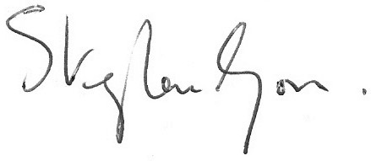
Dr Stephen Goss

